Project Documentation
Movie Metadata

Project Overview
This project focuses on analyzing a movie metadata dataset using Microsoft Excel and Power BI. The goal is to identify trends in movie performance, audience engagement, and key factors influencing IMDB ratings and revenue. The insights derived help in understanding patterns across genres, directors, and actors.

Tools Used
  - Microsoft Excel

  - Power BI

Dataset
  - Source: Movie Metadata Dataset

  - Data contains:

  - Movie Title
  - Director Name
  - Genres
  - IMDB Score
  - Gross Revenue
  - Budget
  - Duration
  - Number of Reviews (Critic & User)
  - Facebook Likes (Actors & Movie)
  - Language & Country
  - Release Year

Steps Followed
• Cleaned the dataset in Excel:
- Removed null values and duplicates
- Standardized column formats
- Handled missing data
- Identified missed Director names for the Movie titles
• Imported data into Power BI:
- Created calculated columns and measures such as Total movies, Total revenue, Total budget, Profit, AVG_IMDB
• Built interactive dashboards:
- Bar charts, Donut charts, Treemaps , Line charts, Column Chart, Map
- KPIs (Total Movies, Avg IMDB Score, Total Revenue)
- Slicers (Genre, Year, Country)

Key Insights
- Movies with higher budgets generally achieved higher gross revenue.
- Certain genres like Action and Adventure tend to have higher IMDB scores.
- Directors with higher Facebook likes often produced more popular movies.
- Most movies are produced in the USA, dominating overall revenue.
- The number of movies released increased significantly after 2000

Screenshots

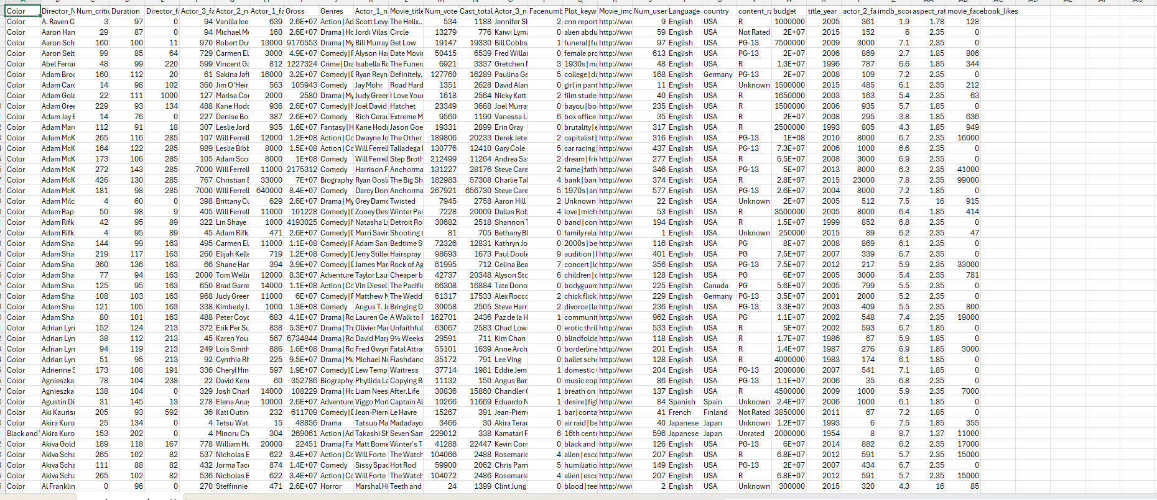

Csv File

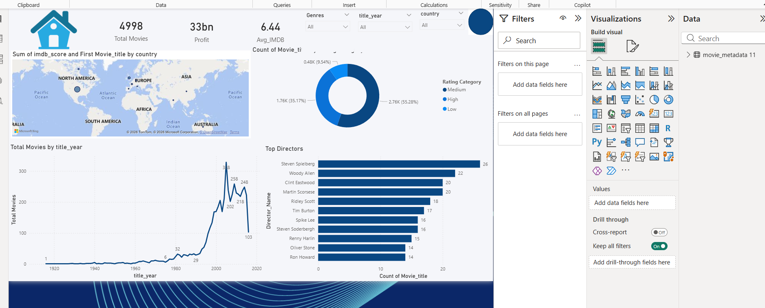

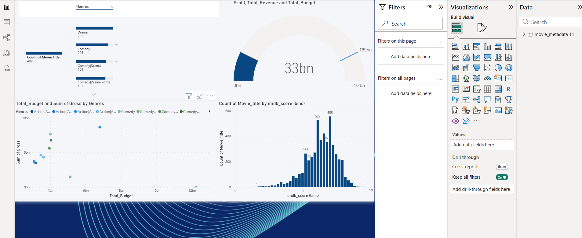

Power BI Dashboards

Files Included
  - ‘movie_metadata 11.csv’ – Cleaned data and basic analysis

  - ‘Mini Project.pbix’ – Power BI dashboard

  - ‘README.md’ – Project description

How to Use
  - Open ‘movie_metadata 11.csv’ to view the cleaned data.

  - Open ‘Mini Project.pbix’ in Power BI Desktop to explore the visuals.

